# Chapter 9: Nature of Science and Physics

**All Lectures Uploaded on YouTube:** [**https://tinyurl.com/fkm9-physics**](https://tinyurl.com/fkm9-physics)

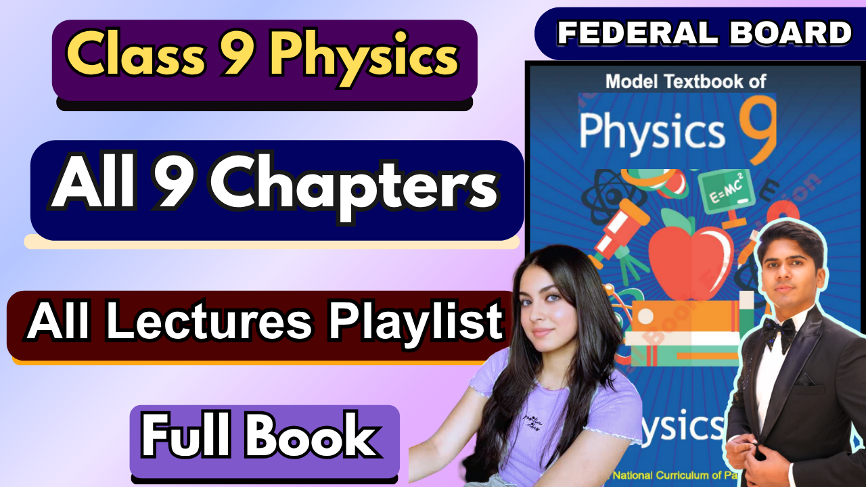

The word "science" has originated from a Latin word "Scientia" which means "to know". Therefore, science is to know about everything in nature. Science is the study of physical nature and its aspects. It contains imagination, experimentation and deduction.

## 9.1 Objectives of Physics

Physics is the study of matter, energy, and their interactions. The main objective of physics is to understand natural phenomena and to apply this knowledge to improve human life. In real life, physics plays a critical role in the development of technologies, innovations, and scientific advancements that we rely on daily.

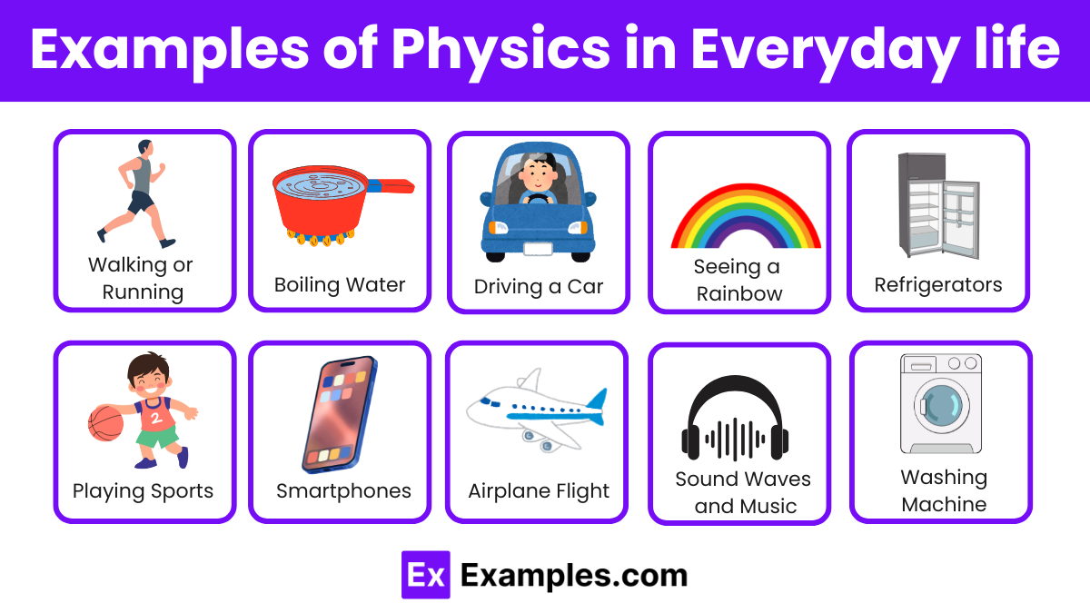

The objective of physics is to offer an understanding of the physical world by developing theories based on observations and experiments. A scientist who specializes in the field of physics is termed a 'physicist'. Physicists engage in theoretical and experimental research to explore and explain the fundamental laws of nature. Physicists express everyday happenings in mathematical formulas. These mathematical formulas are then used by all physicists and engineers to guess the results of their experiments. For example, Isaac Newton (1642-1727) found the laws behind the motion of bodies, which we now use to design rockets that travel in outer space (to the moon and other planets).

For example, physics has enabled the creation of cell phones. These devices work using principles of electromagnetism, signal transmission, and wave propagation. The functioning of GPS and Google Maps in cell phones depends on satellites and precise measurements of time and position, made possible by Einstein’s theory of relativity. Aeroplanes and ships also use signals from GPS to follow their path towards the right destination and stay connected with the control office.

Aeroplanes are another example of physics in action. The principles of aerodynamics, Newton’s laws of motion, and Bernoulli’s principle allow aircraft to lift off, navigate, and land safely.



In nature, birds demonstrate flight by applying the same principles of aerodynamics. Their wings are structured to create lift, and they use energy efficiently for movement, a phenomenon that has inspired modern aviation technology.

## 9.2 Fields of Physics

Physics is a fundamental science that explains natural laws and interacts closely with other sciences. It has many subfields, each focusing on specific aspects of the universe.

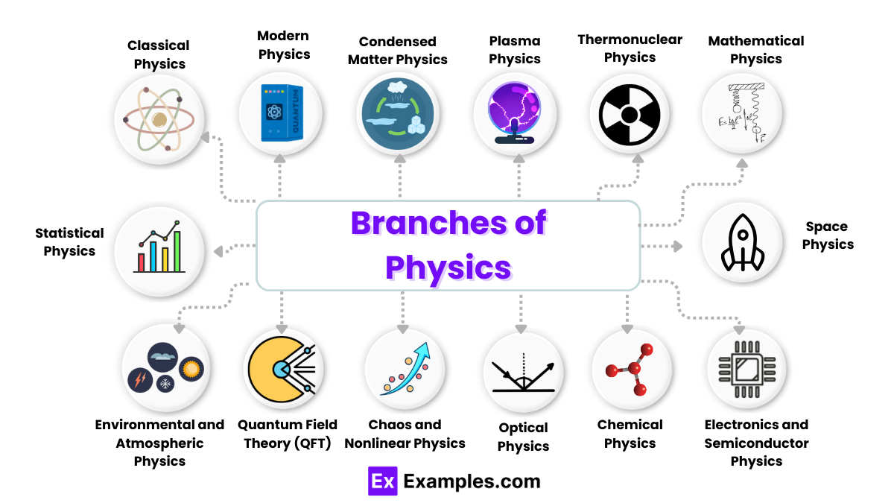

Some fields of physics include:

* **Biophysics:** Application of physics to study biological systems, e.g., medical imaging.
* **Astrophysics:** Study of celestial bodies, e.g., stars, planets, and galaxies.
* **Cosmology:** Study of the origin and evolution of the universe.
* **Thermal Physics:** Study of heat, temperature, and energy transfer.
* **Particle Physics:** Study of fundamental particles like quarks and leptons.
* **Electromagnetism:** Study of electric and magnetic fields, e.g., power generation.
* **Acoustics:** Study of sound waves, e.g., in music and sonar systems.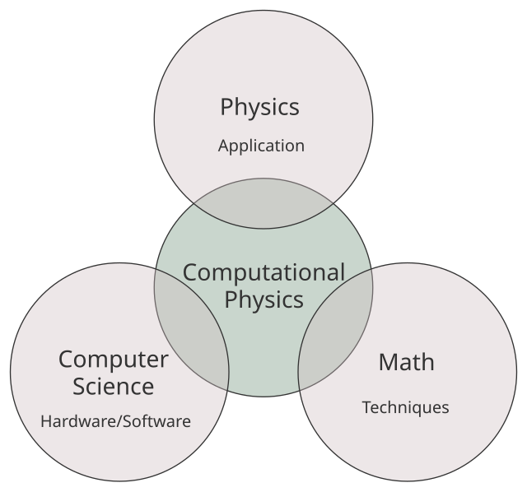
* **Computational Physics:** Use of computer simulations to solve physical problems.
* **Geophysics:** Study of Earth’s structure, e.g., earthquakes and magnetism.
* **Optics:** Study of light, lenses, and vision.
* **Climate Physics:** Application of physics to study Earth’s climate system.
* **Classical Mechanics:** Study of motion and forces at macroscopic levels.
* **Quantum Mechanics:** Study of behavior of matter at atomic and subatomic levels.
* **Relativistic Mechanics:** Study of motion and energy at speeds close to light.

## 9.3 Hypothesis, Theory, and Law

Hypothesis, Theory, and Law have specific meanings in science. The scientific method of research includes formulating hypotheses and testing them to see if they hold up to the realities of the natural world. Successfully verified hypotheses can lead to either theories or laws.

A **hypothesis** is an educated guess or proposed explanation based on limited evidence. For example, a scientist may hypothesize that a new drug can lower blood pressure.

A **theory** is a well-substantiated explanation of natural phenomena, supported by experiments and evidence. For instance, the **theory of evolution** explains how species change over time. Other examples include the **Kinetic Molecular Theory** and **Theory of General Relativity.**

A **law** is a concise statement that describes consistent natural phenomena without explaining why they occur. For example, **Newton’s law of gravitation** describes the attraction between two masses.

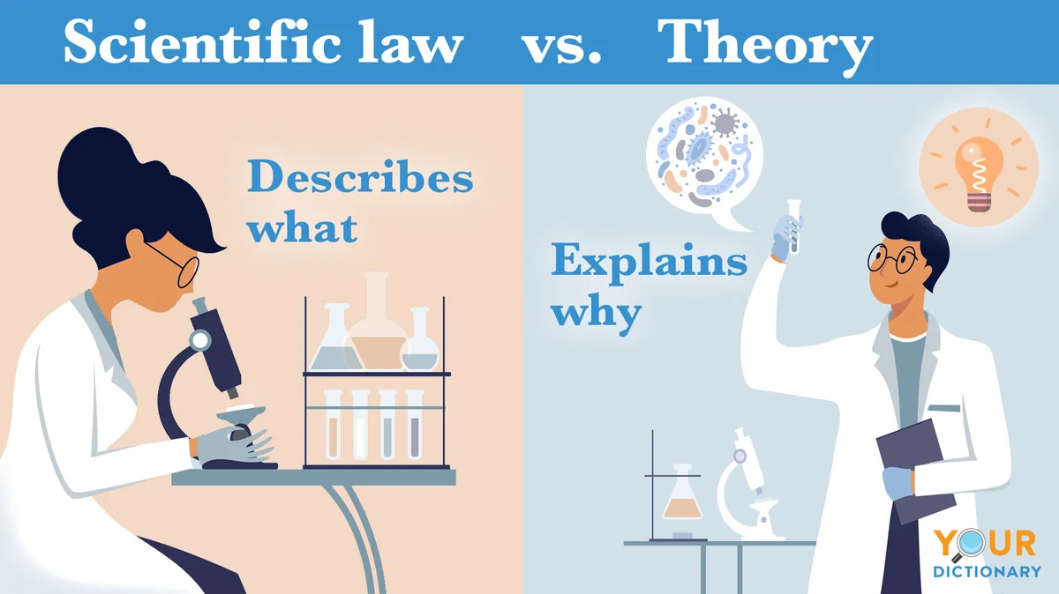

**Difference between theory and law**: A theory explains why phenomena happen, while a law describes what happens.

A scientific law might explain the relationship between two specific forces or between two changing substances in a chemical reaction. Theories are normally more expansive and they focus on the how and why of natural phenomena.

## 9.4 Science, Technology, and Engineering

Science and technology are quite different.

Science is the systematic study of the natural world through observation, experimentation, and analysis. For example, studying the motion of planets is pure science.

Technology is the application of scientific knowledge to create tools and solutions that solve problems. For example, smartphones are a technology developed from advances in physics and electronics.

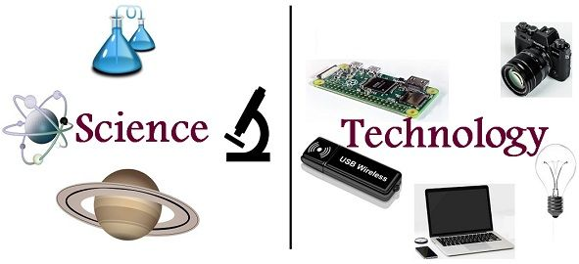

Engineering is the practical application of both science and technology to design, build, and maintain machines, structures, and systems. For example, constructing bridges or developing aircraft engines.

While these fields are distinct, they are interconnected. Advances in science often lead to technological innovations, and engineers use scientific knowledge to create new technologies that, in turn, drive further scientific exploration.



